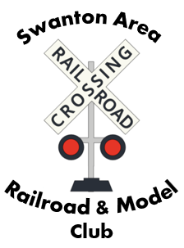
Swanton Area Railroad and Model Club
Submission Form for Website Content

Name _________________________ Date _______________
Division __________
Type of Content (circle one)
Upcoming Division Photo Video Other
Event Information
Please provide detail as to the content you wish to have posted. I will type what you provide with minimal editing.
_________________________________________________________________
_________________________________________________________________
_________________________________________________________________
_________________________________________________________________
_________________________________________________________________
_________________________________________________________________
Please be aware that any photo or video MAY NOT contain members of the public (non-members of the club) who are minors (under the age of 18) without the express written consent of their parent/guardian. It is advisable, also, to minimize or eliminate the use of members of the public who are non-minors.

Material may be emailed to me at djheban@outlook.com, but the information on this form must accompany your submission.

